

**Adama science and Technology University**

**School of Electrical Engineering and**

**Computing**

**Computer science and engineering department**

**FSE project for 3rd year 1ST semester**

**MOBILE WATER UTILITY BILL PAYMENT SYSTEM FOR WSSA**

**BY:**

1. **Mama Mohammed**
2. **Muhidin Misbah**
3. **Mubarek Ismael**
4. **SeidShemsu**
5. **ShemsedinSeifedin**

**Submitted to**: Inst. Anteneh

**Date**:

**Acronym**

WSSA……………………Adama city administration water supply and swage service enterprise

DB…………………………Database

HTML……………………Hyper Text Markup Language

CSS………………………Cascading Style Sheet

SQL…………………….Structural Query Language

PHP…………………….Hypertext Processor

UML…..........................Unified Modeling Language

Contents

CHAPTER ONE 5

1.1. Introduction 5

1.1.1. Background 5

1.1.2. Statement of the Problem 6

1.2. Team composition 6

1.3. Objectives of the project 7

1.3.1. General Objective 7

1.3.2. Specific Objectives 7

1.4. Feasibility 7

1.4.1. Operational Feasibility 7

1.4.2. Legal Feasibility 7

1.4.3. Economic Feasibility 8

1.5. Scope andLimitation 8

1.5.1. Scope of the project 8

1.5.2. Limitation of the project 8

1.6. Methodology 8

1.6.1. Data Collection Methodology 8

1.6.2. Development method 9

1.7. Significance of the project 9

1.8. Development tools 9

1.8.1. Software tools 9

1.9. Overview of the project phase 10

1.10. Project Plan 11

1.10.1. Task and schedule 11

CHAPTER TWO 11

2.1. Description of the existing system 11

2.1.1. major functions of the current system 11

2.1.2. Users of the current system 12

2.1.3. Drawback of the current system 12

2.2. Business rule Identified in the Existing System 12

2.2.1. Forms and other Documents of the Existing System 13

2.6 Expected Outcomes of the Project 14

CHAPTER THREE 14

3. Proposed system 14

3.1. overview: 14

3.1.1. Functional requirements: 14

3.1.2. Non-Functional Requirements 16

3.2. System Model 18

3.2.1. Scenarios 18

3.3. Object Model 37

3.4. Dynamic model 38

3.5.Class diagram 53

# CHAPTER ONE

## Introduction

Now days, clean water is one of human’s necessity to stay alive and many companies across the world proved this necessity to their customers. And customers pay monthly bill for their consumption . Paying a utility bill in Ethiopia and most developing nations is time consuming. It takes more than a quarter a day or more, to pay a utility bill in most of these nations with queues usually several meters long in any of water supply service office. On most days, the water supply offices are ﬁlled with long queues of hundreds of individuals waiting to pay a range of these bills in cash. A lot of unproductive hours are spent queuing up to pay and also to make simple inquiries or receive responses. These reasons actually dominate the customers’ reasons for the branch visits, making the whole payment process needlessly complicated. On the other hand, the utility company is also tasked to a greater extent with receiving, reviewing, tracking and manually clearing each bill, which is and continues to be a laborious time intensive undertaking.

### Background

The water supply history of the Adama Town begins in early 1940’s EC and transferred to the newly established WSSA, under the Military Government, in 1975 EC thereafter, the supply system was in action by WSSA until it was run again by the new Federal Democratic Government taking power from Guinbot 1983 EC.

Now WSSA provides water to about 67,392 customers where about 66,092 are active customers and 1,300 who are not active. WSSA has now 6 branches in adama

1. Head office (mebrat)

2. college (in front of ASTU main gate)

3. Amede

4. Genb

5.Dukete

6.Aba geda

And only the top 4 branches provided bill payment service to their customers the other branches are for giving suggestion or for reporting a problem. All this branches are connected through VPN which is provided by Ethiopian telecom. And Customers can pay their bills at any of these 4 branches.

### Statement of the Problem

There is already a computerized system in WSSA which is a server based desktop application. In the system every employee does his job as the system provides. key problem of WSSA’s is the bill payment system customers have to go to WSSA’s branches directly and spent queuing up to pay .customers waste a lot of unproductive time ,Therefore in this project customers are able to pay their bill from anywhere just using their mobile phone so that it can save the time wasted to pay their bills and also this system enables an error free billing system.

## Team composition

|  |  |  |  |
| --- | --- | --- | --- |
| Title | Water utility mobile billing system | | |
| Team composition | Name | Email | Roll |
| Mama Mohammed | [mastermama31@gmail.com](mailto:mastermama31@gmail.com) | Coordinate and lead the Members,Design, Architecture, Documentation |
| Mubarek Ismael |  | Requirement Analysis, Design, Architecture, implementation and Documentation |
| Muhidin misbah |  | Requirement Analysis, Design, Architecture, implementation and Documentation |
| Seidshemsu |  | Requirement Analysis, Design, Architecture, implementation and Documentation |
| ShemsedinSeifedin |  | Requirement Analysis, Design, Architecture, implementation and Documentation |
| Advisor | Ins :Anteneh | | |

## Objectives of the project

### General Objective

The main objective while implementing the project this mobile Billing System was tominimize the work and at the same time increase the speed of the work done and also its enables the customers to pay their bill from anywhere ontime.

This Mobile Billing System is developed as per seeing the increasing requirement to speed up the work and incorporate a new work culture. Thus new billing system has been proposed to reduce manualwork, improving work efficiency, saving time and to provide greater flexibility and user-friendliness as the system previously followed was totally manual one with lots of errors.

### Specific Objectives

* Analyze the existing system
* Develop well organized data base system to store the customer’s information or data and also to add new customers and to update the customer’s information or data.
* To give fast and accurate access for customers
* To design Web based Application for customers
* To design a mobile application for online bill payment for customers.
* Collecting data about the organization

## Feasibility

### Operational Feasibility

This system brings better achievement for the operations performed in serving its customers. So that one can say that the system is operationally feasible.

### Legal Feasibility

This project does not violate rules and regulations of the governments as well as the organization (WSSA). The system being built is for the sake of productivity of the organization, so that the project is legally feasible.

### Economic Feasibility

Here we have stated the costs related to the project and the benefits that are going to be gained after the completion of the project by performing as a cost benefit analysis.

* Increase accuracy
* It minimizes the work load of the employee
* Error reduction
* Reduction of time for bill payment
* Increase speed of activities to the system

Because of these benefits this project is economic feasibility.

## Scope andLimitation

### Scope of the project

This project includes water billing and customer management web application and mobile billing system and other related services for customers are: -

* Online payment through mobile phone.
* Customer registration and retrieval
* On the registration of the maintain material.
* On the registration of meter reading.
* On the registration of the payment.
* Bill calculation and printing.

### Limitation of the project

* The system is dependent on internet connection.
* It is completely dependent on computers and smart phones.
* The system needs IT professional, but in our country there are shortage of computer and computer teacher.
* The system cannot be accessed offline.

## Methodology

### Data Collection Methodology

There are different methodologies available for collecting information (data gathering methods) from the users and administrators of WSSA. During requirement collection methods we have used some techniques among them:

1) Observation: we observed the existing systems (water billing systems) how it operate and how customers communicate with the organization (WSSA).

2) Interview: In addition to observation we interview both the customers and the WSSA’s administrators. We interview that the customers about the problems of the existing systems and also we interview the service administrators how they manage and store the customers information and data. Based on the gathered data from the interview made in the water supply service that has been organize and process, the existing problem has been identified.

3) Document analysis: Internet and some researches will be used as source to collect information related to this project.

### Development method

Agile modeling method is suitable for this project because of

* Our highest priority is to satisfy the customer through early and continuous delivery of valuable system.
* The system mainly depends on code rather than design.
* Even if a change is needed in the middle of the development it is possible to make the change.
* Mainly focus on the simplicity of the system.
* Lastly this model helps for making a better decision.

## Significance of the project

The main Significance of this system is reduces the customers accessing time to get service from the organization.

* It minimizes the customers losing time when they want to access service from the organization.
* It provides timely information and also Process Customers request on time.
* It can easily update customer’s record.
* Reduce material loss
* It increases performance of the organization
* Enhance employee morale of the organization by providing quality service.
* Improves the confidence of the system users.

## Development tools

### Software tools

|  |  |  |
| --- | --- | --- |
| No | Tools | Used for |
| 1 | **Android studio** | Android application development |
| 2 | **Html 5** | web-designing |
| 3 | **Mysql** | Database |
| 3 | **CSS** | layout design, content decoration in user interface design |
| 4 | **PHP** | Web-designing |
| 4 | **Java script** | validating client side inputs and forms |
| 5 | **Microsoft word** | Writing documentation |
| 6 | **Enterprise architect 12** | Diagram |

## Overview of the project phase

This mobile application project includes the following phases:

* Requirements Analysis: This phase begins with analyzing what exactly the system has to do.
* Functional Specification: At this phase, determining what exactly the target system must do and the premises for its implementation. All requirements should be thoroughly defined and documented.
* Software Architecture and Test Plan: In this phase, it is necessary to determine the system components covering your requirements and the way these components will work together.
* Implementation (Coding) and Testing: In this phase, developing the mobile application and making sure it is error free takes place.
* Release: after the development and testing process is completed the software will be released.
* Maintenance: The task of this phase is the proper functioning of the software. To improve a product or system, it should be continuously maintained. Software maintenance involves detecting and correcting errors, as well as extending and improving the software itself.

## Project Plan

### Task and schedule

|  |  |  |  |
| --- | --- | --- | --- |
| Roll  no | phases | Required time | Tasks |
| 1 | Requirements planning phase | One week | Combine elements of system planning and system analysis phases.  Members discuss and agree on project scope, constraints and system requirements. |
| 2 | User design phase | One week | Develop system model and prototypes. |
| 3 | Construction phase | Two week | Focus on program and application development task. |
| 4 | Cutover phase | Two week | Resemble the final task include testing. |

# CHAPTER TWO

## 2.1. Description of the existing system

Currently WSSA uses a computerized system for giving service to its customers. And this existing system currently performs different activities including registration of new customer, bill generation, report generation. But the payment of the customers is not in timely manner and hence the whole system is not properly organized. Even if the customers want to pay there is not facility to payment method which can be achieved quickly. Paying utility bills for such basic services like water still takes more than a quarter a day in Ethiopia and many other nations in Africa. Customers to these utility companies have to spend very unproductive hours queuing to pay bills in form of cash at the water supply service.

### 2.1.1. major functions of the current system

The current system performs the following tasks :-

**Registration new customers** – new customers are registered by the system.

**Employment**- staffs like payroll payment for the employee is made this system

**Bill generating-** every progress of a student is recorded and stored

**SMS notification -**notify the customers the payment date and the amount of the consumption.

**Finance-** financial income and budget data of the company are stored

### 2.1.2. Users of the current system

The current system has the following users

* Administrators
* Customers
* Employees
* IT men
* And other workers

### 2.1.3. Drawback of the current system

* Currently, The system of bill payment is totally manual.
* The manual system is slow then the computerized system.
* It is very time consuming.
* It is required more man power to serve all customers.

### 2.2. Business rule Identified in the Existing System

* Business rule is a rule in which the organization uses it to perform any activities or invoice. Water meter is the property of the Authority therefore only the Authority has the right to install, to remove, to change, transfer and to clean to inspect a water meter.
* The customer shall notify the authority as soon as he is aware that the meter is broken or has been damaged.
* The Authority shall demand the payment of the water charge from the customer According to its tariff and the consumption of water as show by the meter.
* Unless it is proved that the meter is not making correct reading, or is broken, the reading shall be accepted by the Authority and the customer.
* Where the correctness of the meter is doubtful the customer may request the inspection of the authority. The authority may also at any time inspect the meter as its own initiative.
* Where the customer fails to pay the require water charge, the Authority shall give him two consecutive periods of months within punishment and finally the water bill removes from customers.

### 2.2.1. Forms and other Documents of the Existing System

The following are forms and other documents used in the existing system. Contract for supply of water: date, full name, address, woreda, kebele, house no, placement no, house phone no, mobile no, email, service type, purpose of water is to be signature, contract no, power approved, application tariff, purpose of electricity is to be supply, deposit birr, connector birr, total, receipt, customer sign and authority sign.

#### 2.2.1.1. Tables for current tariff of water consumption

##### The following table shows current tariff of water consumption for private customers(households)

|  |  |  |
| --- | --- | --- |
| Number | Consumption | Tariff/Birr |
| 1 | From 0 - 5 m3 | 5.25 |
| 2 | From 6 - 10m3 | 6.30 |
| 3 | From 11 - 30m3 | 7.90 |
| 4 | From 30m3 and above | 8.95 |

Water consumption table 1

##### The following table shows current tariff of water consumption for commercial sectors

|  |  |  |
| --- | --- | --- |
| Number | Consumption | Tariff/Birr |
| 1 | From 0 - 5 m3 | 6.25 |
| 2 | From 6 - 10m3 | 8.30 |
| 3 | From 11 - 30m3 | 9.35 |
| 4 | From 30m3 and above | 10.30 |

Water consumption table 2

##### The following table shows current tariff of water consumption for private government and NGO sectors

|  |  |  |
| --- | --- | --- |
| Number | Consumption | Tariff/Birr |
| 1 | From 0 - 5 m3 | 5.25 |
| 2 | From 6 - 10m3 | 6.30 |
| 3 | From 11 - 30m3 | 7.90 |
| 4 | From 30m3 and above | 8.95 |

Water consumption table 3

##### The following table shows current tariff of water consumption for community

|  |  |  |
| --- | --- | --- |
| Number | Consumption | Tariff/Birr |
| 1 | From 0 m3  and above | 4.25 |

Water consumption table 4

##### The following table shows current tariff of water consumption for hydrant

|  |  |  |
| --- | --- | --- |
| Number | Consumption | Tariff/Birr |
| 1 | From 0 m3  and above | 9.10 |

Water consumption table 5

### 2.6 Expected Outcomes of the Project

Finally, we expect from our project it saves time, money and energy for customers and employees. Customers can get quick and fair access of WSSA water supply. Our system can give satisfaction for employees and Customers because the system avoids fault activities.

# CHAPTER THREE

## 3. Proposed system

### 3.1. overview:

The proposed system solves the problem of the existing system. The main aim of the proposed system is to implement web-based water billing and customer service management system for WSSA which allows easily register customer, maintenance order request, search payment, and generate report. So, the proposed system benefits both customers and the water supply service.

### 3.1.1. Functional requirements:

The functional requirement for the system describes the functionally or services that the system is expected to provide. It is a system requirement that describes an activity or process that the system must perform. The users first know how to use the system. The developed system is expected to provide the following functionalities:

**Manager expert:**

* The system should allow to the manager to view reports.
* The system should allow to the manager to Create User accounts
* The system should allow to the manager to Update User Accounts.
* The system should allow to the manager to login.
* The system should allow to the manager to Delete User accounts.

**Service** **expert:**

* The system should allow to the Customer Service Expert to delete customers.
* The system should allow to the Customer Service Expert to register new customers.
* The system should allow to the Customer Service Expert to update customer’s info.
* The system should allow to the Customer Service Expert to Delete, add &Update new customers.
* The system should allow to the Customer Service Expert to assign maintenance.

Technical expert:

* The system should allow to the Technical expert to record payment.
* The system should allow to the Technical expert to register meters.
* Technical expert have duties to approve maintenance.

**Customer expert:**

* The system should allow to the customer to view their payment.
* The system should allow to the customer to request maintenance order.
* The system should have login accounts.
* The system should allow to the customer to make payment.
* The system should allow to the customer to view maintenance date.
* The proposed system should have authentication system for Manager,Customer, Service expert.
* The new system should hold customer’s personal information.
* The proposed system should add data from different user of the system to the DB our proposed system should update, delete and add records as needed.
* Bill calculates.
* Approve new customer’s application: support the record of the new customer tothedatabase if the organization adds more customers.

### 3.1.2. Non-Functional Requirements

Non-functional requirement describes invisible aspects of the system that are not directly related to the system. Unlike functional requirement the non-functional requirement deals with additional quality of the system.

1. **Users interface requirement:**

* User interface should be menu driven and attractive.
* The interface should be user friendly.
* The system should support error-handling mechanism that the system guidesthe user what will be the next action.

1. **Authentication Requirement:**

* The system support user name and password to authentic.
* The system has different privilege to protect intruding.

1. **Error handling requirement:** The system has error handling mechanisms that is, as errors occur it will not stop functioning rather provide error manages and back to the previous page to give chance to reenter data and process the task by beyond the error.
2. **Availability**: The system is available for 24 hours. Unless some failures an internet connection problem occurs or light goes off, our system is available at any time.
3. **Efficiency**: Searching a customer record should not take more time

• The system displays in every window.

1. **Scalability:** Any increase in the number of user shall not degrade system availability to an extent noticeable by any users.
2. **Usability:**

* More efficient to use it takes less time to accomplish a particular task.
* Easier to learn operation can be learned by observing the object.
* To give more satisfaction to use our system we prepare manual and documentation Facility

✓ Unauthorized person should not use the system; rather just view the main page.

✓ No one can change the password without login to the system.

1. **Reliability**: The system will consistently perform its intended function.
2. **Hardware consideration:** The following sub-sections discuss the various aspect of hardware requirement.

* computer
* Android running smart phone
* Server

1. **Software consideration:**

* Network connection
* Server connection
* MYSQL server
* Enterprise architecture 12
* PHP
* CSS
* Java script
* HTML5
* Android studio
* Microsoft word

**XI. Performance requirement:**

System performance is characterized by the amount of useful work accomplished by a system compared to the time and resources used.

Depending on the context, good system performance may involve one or more of the following:

1. Every employee can access the system.
2. Works can be performed in a short period of time.
3. Customers get quick access.

## **3.2. System Model**

### 3.2.1. Scenarios

**Scenario: 1**

**Name of scenario**: Register customer  
**Participating actors**: Customer service expert  
**Entry condition**:✓Internet connection should be available.  
✓They have to navigate to organization’s URL  
✓The user should have valid username and password and must login  
**Flow of events**:1. The customer service expert logs into his/her page  
2. Chooses register new customer tab from the category  
3. The customer service expert enters all the necessary information

4. The customer service expert fills the table and click **ADD** button

5. The system displays a success message to the customer service expert

**Exceptional flow**:if the customer service enter wrong information or did not entered required information the system will display wrong input message

**Scenario: 2**

**Name of scenario**: update customer  
**Participating actors**: customer service expert  
**Entry condition**:✓Internet connection should be available.  
✓They have to navigate to organization’s URL  
✓The user should have valid username and password

**Flow of events:**

1. The user opens the system
2. Chooses manage customer tab
3. The system displays category to choose target
4. The user chooses target group and choose specific user
5. Looks into users profile and edits if needed
6. Clicks **UPDATE** button

**Scenario: 3**

**Name of scenario**: Delete Customer   
**Participating actors**: Customer Service expert  
**Entry condition**:✓Internet connection should be available.  
✓They have to navigate to organization’s URL  
✓The user should have valid username and password  
**Flow of events**:

1. The user opens the system
2. Chooses manage customer tab
3. The system displays category to choose target
4. The user chooses target group and choose specific user
5. Clicks **DELETE** button to remove the customer for active customer list.

**Exceptional flow**:if the customer service delete wrong customer he/she can undo the deleted customer.

**Scenario: 4**

**Name of scenario**: assign technician   
**Participating actors**: Customer Service expert  
**Entry condition**:✓Internet connection should be available.  
✓They have to navigate to organization’s URL  
✓The user should have valid username and password  
**Flow of events**:

1. The user opens the system
2. Chooses request maintenance tab
3. The system provides the user with a form to be filled
4. The user clicks **REQUEST MAINTENANCE** button to assign the maintenance

**Scenario:5**

**Name of scenario**: Record meter reading  
**Participating actors**: Technician  
**Entry condition**:✓Internet connection should be available.  
✓They have to navigate to organization’s URL  
✓The user should have valid username and password and must login  
**Flow of events**:1. The technician logs into his page  
2. Chooses meter reading tab from the category  
3. The system displays query table to choose target  
4. The user chooses customers name  
5. The technician enters all the necessary information

6. The system displays customer’s database for that specific target  
7. The system displays table of meter reading for that customer  
8. The technician fills the table and click **SAVE** button

**Exceptional flow**:if the technician records incorrect meter reading, he/she can correct it by clicking **EDIT** button

**Scenario: 6**

**Name of scenario**: Approve maintenance  
**Participating actors**: Technician  
**Entry condition**:✓Internet connection should be available.  
✓They have to navigate to organization’s URL  
✓The user should have valid username and password

✓The maintenance must be requested  
**Flow of events**:

1. The technicianlogs into his page  
2. Chooses approve maintenance tab from the category  
3. The system displays the requested problem andcustomer information to the technician  
4. The technician checks the problem and customers information  
5. Technical takes the request from the customer.  
6. The technician fills the information and click **APPROVE** button

**Scenario: 7**

**Name of scenario**: Register meter  
**Participating actors**: Technician  
**Entry condition**:✓Internet connection should be available.  
✓They have to navigate to organization’s URL  
✓The user should have valid username and password  
**Flow of events**:

1. The technician logs into his page  
2. Chooses register meter tab from the category  
3. The system displays the requested meter and customer information to the technician  
4. The technician checks the meter and customers information  
5. The technician fills the information and click **SAVE** button

**Scenario: 8**

**Name of scenario**: Login

**Participant actors**: all users

**Entry condition:**

* Internet connection should be available.
* If they are WASSA employees they have to navigate to WASSA URL.
* If they are customers, they have to open their installed WASSA app.
* They should submit a valid username and password.

**Flow of event:**

1. The use opens the login page.
2. Enters username and password.
3. Clicks login button.
4. The user gets appropriate page.
5. If the user forgets his/her username/password, then click forgot password/username link.
6. Password recovery page will be displayed.

**Exceptional flow:**

-if the user enters invalid username and password, the system notifies to enter the correct one.

**Scenario:9**

**Name of scenario:** create account.

**Participant actors:** Manager

**Entry condition:**

1. Internet connection should be available.
2. If they are WASSA employees they have to navigate to WASSA URL.
3. She/he should submit a valid username and password.

Flow of condition:

1. Login page is presented.
2. Manager fills the required fields.
3. Click on the create tab.
4. Fills the required spaces.
5. Click create button.
6. Verification for success will display.

**Exceptional condition:**

If the manager did not fill all required fields or filled incorrect it will load the create tab with error message.

**Scenario: 10**

**Name of scenario:** update account.

**Participant actors:** Manager

**Entry condition:**

1. Internet connection should be available.
2. They have to navigate to WASSA URL.
3. She/he should submit a valid username and password.

**Flow of condition:**

1. Login page is presented.
2. Manager fills the required fields.
3. Click on the create tab.
4. Fills the required spaces.
5. Click update button.
6. Verification for success will display.

**Exceptional condition:**

If the manager did not fill all required fields or filled incorrect it will load the update tab with error message.

**Scenario: 11**

**Name of scenario:** delete account.

**Participant actors:** Manager

**Entry condition:**

* Internet connection should be available.
* They have to navigate to WASSA URL.
* She/he should submit a valid username and password.

**Flow of condition:**

1. Login page is presented.
2. Manager fills the required fields.
3. Click on the delete tab.
4. Select from employees.
5. Click delete button.
6. Verification for success will display.

**Scenario: 12**

**Name of scenario:** view report.

**Participant actors:** Manager

**Entry condition:**

* Internet connection should be available.
* They have to navigate to WASSA URL.
* She/he should submit a valid username and password.

**Flow of condition:**

1. Login page is presented.
2. Manager fills the required fields.
3. Click on the view report tab.
4. Report will be displayed.

**Scenario: 13**

**Name of scenario:** make payment

**Participating actors:** customer

**Entry condition:**

* Internet connection should be available.
* The user should have the application.
* The user should have valid meter number and password

**Flow of events:**

1. The user opens the application

2. Enter meter number and password

3. Click view payment button

4. The system displays current payment value of customer.

5. Click pay button

**Exceptional flow:**

* If the user enters invalid meter number or password the application will toast incorrect meter number or password message.
* If the user does not have sufficient balance the application will toast insufficient balance message.

**Scenario: 14**

**Name of scenario:** view history

**Participating actors:** customer

**Entry condition:**

* Internet connection should be available.
* The user should have the application.
* The user should have valid meter number and password.

**Flow of events:**

1. The user opens the application.
2. Enter meter number and password
3. Click history button
4. The application will display payment history of the customer.

**Exceptional flow:**

* If the user enters invalid meter number or password the application will toast incorrect meter number or password message.

**Scenario: 15**

**Name of scenario:** send request

**Participating actors**: customer

**Entry condition:**

* Internet connection should be available.
* The user should have the application.
* The user should have valid meter number and password.

Flow of events;

1. The user opens the application.
2. Enter meter number and password
3. Click send request button
4. Write description of the problem
5. Click submit

Exceptional flow:

* If the user enters invalid meter number or password the application will toast incorrect meter number or password message.3.2.2 Use case models

#### Actor identification

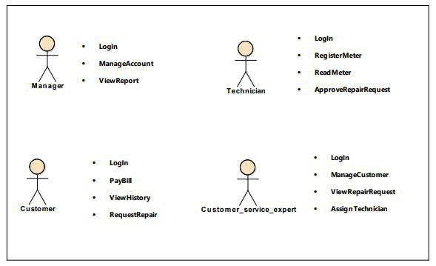

#### Use case identification:

Our system includes the following use cases: -

* View payment
* View Maintenance Assigned Date
* Request Maintenance Order
* Login
* Maintenance Request
* Payment record
* Bill Calculate
* Accept Maintenance
* Generate Report
* Maintenance approve
* Record meter reading
* View history
* Assign technician
* Delete Customer
* Update customer
* Register customer
* Register meter
* Create Account
* Account update
* Delete Account
* View report
* Bill payment

#### USE CASE DIAGRAM

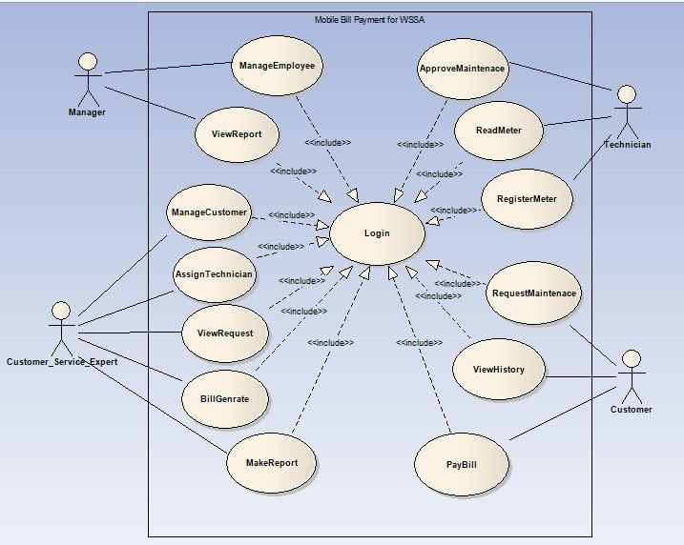

#### USECASE DISCRIPTION

Use case documentation for register customer

|  |  |
| --- | --- |
| Use case name | Register customer |
| Description | It registers a new customer and fills the data to the database. |
| Actor | Customer Service expert |
| Pre-condition | Customer service expert first login using its own username and password |
| post condition | Data of new customer saved into database |
| Racecourse action (Flow of event): | 1. Customer service expert opens the home page.  2. Customer service expert enters its own username and password to login.  3. Customer service expert clicks the register new customer button  4.Enter the correct & all necessary information.  5. Initiate the system to sends to the organization.  6. The use case ends. |
| Exceptional flow | If the user enters invalid username or password the application will toast incorrect username or password message.  -if the expert enters invalid information the system will display invalid input message. |

Use case documentation for update customer

|  |  |
| --- | --- |
| Use case name | Update customer |
| Description | It allows to update the data of the customers. |
| Actor | Customer service expert |
| Precondition | The user must login to Customer service expert page |
| Post- condition | The information of the customer will be updated and saved to the database. |
| Basic course of action (Flow of event): | 1. Customer service expert open the Customer service page  2. Customer service expert inserts the login address on the page.  3. the Customer service expert finds the customer using the find button  4. the Customer service expert updates and saves the update  5.End use case |
| Exceptional flow | - If the user enters invalid username or password the application will toast incorrect username or password message.  -if the customer does not exist display no match found message and return to step 3. |

Use case documentation for delete customer

|  |  |
| --- | --- |
| Use case name | Delete Customer |
| Description | It removes customer from the service. |
| Actor | Customer service expert |
| Precondition | The Customer service expert must login to customer service page |
| Post- condition | The customer would be removed from the active customer list |
| Basic course of action (Flow of event): | 1. Customer service expert open the Customer service page  2. Customer service expert inserts the login address on the page.  3. the Customer service expert finds the customer using the find button  4. the Customer service expert removes the customer  5.End use case |
| Exceptional flow | - If the user enters invalid username or password the application will toast incorrect username or password message.  -if the customer does not exist display no match found message and return to step 3. |

Use case documentation for assign technician for maintenance

|  |  |
| --- | --- |
| Use case name | Assign technician |
| Description | It requests for maintenance to the technician |
| Actor | Customer service expert |
| Precondition | The Customer service expert must login to customer service page |
| Post- condition | Request would be sent to the Technician page |
| Basic course of action (Flow of event): | 1. Customer service expert open the Customer service page  2. Customer service expert inserts the login address on the page.  4. Customer service expert clicks Request maintenance button  5. Enter the correct & all necessary information  5. clicks request button.  6.End use case |
| Exceptional flow | - If the user enters invalid username or password the application will toast incorrect username or password message.  -if there is no request maintenance display no request message return to step 3 |

Use case documentation for record meter

|  |  |
| --- | --- |
| Use case name | Record meter reading |
| Description | It allows meter reading to register to the database. |
| Actor | Technician |
| Pre-condition | Technician first login using its own username and password |
| post condition | Technician registers the meter reading into database |
| Racecourse action (Flow of event): | 1. Technician opens the home page.  2. Technician enters its own username and password to login.  3. Technician clicks the record meter reading link.  4.Ente the correct & all necessary information.  5. Initiate the system to sends to the organization.  6. The use case ends. |
| Exceptional flow | -if the technician records incorrect meter reading display invalid input message and return to step 4. |

Use case documentation for Approve maintenance

|  |  |
| --- | --- |
| Use case name | Approve maintenance |
| Description | It allows receive and approve customer maintenance request process. |
| Actor | Technician |
| Precondition | 1.The customer should ask the request maintenance  2.The user must login to technicians page |
| Post- condition | Customer maintenance request should be transferred and service being delivered. |
| Basic course of action (Flow of event): | 1.Technician open the technician page  2. Technician inserts the login address on the page.  3. System validates the address.  4. Technician checks and see the problem.  5. Technician Approves the request.  6.End use case |
| Exceptional flow | - If the user enters invalid username or password the application will toast incorrect username or password message.  -if the customer did not send any maintenance request the system displays no request is detected message and return to step 1. |

Use case documentation for Approve maintenance

|  |  |
| --- | --- |
| Use case name | Register meter |
| Description | It allows the customer maintenance request process. |
| Actor | Technician |
| Precondition | The Technician must login to technicians page |
| Post- condition | The new meter registered in the database of the organization |
| Basic course of action (Flow of event): | 1.Technician open the technician page  2. Technician inserts the login address on the page.  3. System validates the address.  4. Technician enters the required information.  5. Finally the technician clicks save button.  6. End use case |

|  |  |
| --- | --- |
| Use case name | Login |
| Description | It allows employees to login into the system. |
| Actor/s | All users |
| Pre-condition | The employees should have registered into the system. |
| Post-condition | The employees will be login in to the system and able to access the required home page. |
| Basic course of action (Flow of event): | Step 1. Initiated when the employees want to login into the system.  Step2. The system Displays the employees Login Page.  Step3.The employees fill the inputs his/her user name and password.  Step4. The system verifies the username and password.  Step5.The system displays the appropriate page of the employees.  Step6. The use case ends.  From the above steps Step 1 and step 3 Actors action whereas Step 2 Step 4, Step 5 and Step 6 System response. |
| Exceptional flow | The username/password is invalid.   1. The system displays error message. 2. The system continues at step 2 to fill user name and password again. |

Use case for create account.

|  |  |  |
| --- | --- | --- |
| Use case name |  | Create Account |
| Description |  | Used to create account for employees. |
| Actor |  | Manager |
| Pre- condition: |  | The employees should be Employs of the WSSA. |
| Basic course action (Flow of event): |  | Step1.The manager wants to create account.  Step2.The system displays create account page.  Step3.The manager fills the required information and submits it.  Step4.The system validates the information.  Step5.The system registers the employees into the system database.  Step6.The system displays confirm message.  Step7.The use case ends. |
| Post-condition |  | The user account successfully created. |
| Exceptional flow | | Invalid information entry.   1. The system displays error message. 2. Go to step 2 to fill again. |

Use case for updating account

|  |  |
| --- | --- |
| Use case name | Account update. |
| Description | It allows the manager to update employee account. |
| Actor | Manager. |
| Precondition | The account must be presented in the System data base. |
| Basic course of action (Flow of event): | Step1.The manager wants to update account.  Step2.The system displays update account page.  Step3.The manager fills the required information and submits it.  Step4.The system validates the information.  Step5.The system update the employee into the system database.  Step6.The system displays confirm message.  Step7.The use case ends. |
| Post-condition | The user account successfully updated. |

Use case for delete account.

|  |  |
| --- | --- |
| Use case name | Delete Account |
| Description | It Allows Manager to delete employees account |
| Actor | Manager |
| Precondition | To delete the employees account must be registered in the database. |
| Basic course of action (Flow of event): | Step1.The Manager wants to delete account.  Step2.The system displays the delete account page.  Step3. The Manager press on delete button.  Step4.The system validates the information.  Step5.The account is deleted from the system.  Step6.The system displays confirm message.  Step7. The use case ends.  From the above steps Step 1 and step 3 Actors action whereas Step 2 Step 4, Step 5, Step 6 and Step 7 System response. |
| Post- condition | The user account successfully deleted. |
| Exceptional flow | If the selected account is invalid.   1. The system displays error message. 2. Go to step2 to select the delete account again. |

Use case for view report.

|  |  |
| --- | --- |
| Use case name | View report |
| Description | It allows viewing report from the experts. |
| Actor | Manager |
| Pre-condition | They should have prepared data by the employee of the organization. |
| Post-condition | The manager sees the report prepared by the office employees. |
| Basic course of action (Flow of event): | Step1. The manager opens the home page.  Step2. The manager Enter his/her user name and password.  Step3. System validates the address.  Step4. The manager View the prepared report.  Step5. End use case.  From the above steps Step 1, Step 2 and Step 4 Actors action whereas Step 3, and Step 5 System response |
| Exceptional flow | - If the user enters invalid username or password the application will toast incorrect username or password message. |

|  |  |
| --- | --- |
| Use case name | Make payment |
| Use case description | To pay monthly payment of the bill |
| Actor | Customer |
| Pre-condition | User must be registered on database of service provider |
| Post-condition | Display history of payment |
| Main flow | 1. The user opens the application  2. Enter meter number and password  3. Click view payment button  4. The system displays current payment value of customer.  5. Click pay button |
| Exceptional flow | * If the user enters invalid meter number or password the application will toast incorrect meter number or password message. |
| Include | Login |
| Business rule | - |
| Frequency of use | When needed |

|  |  |
| --- | --- |
| Use case name | View history |
| Use case description | To see history of payments of each month |
| Actor | Customer |
| Pre-condition | User must be registered on database of service provider, login |
| Post-condition | Display all history of payment |
| Main flow | 1. The user opens the application. 2. Enter meter number and password 3. Click history button 4. The application will display payment history of the customer. |
| Exceptional flow | * If the user enters invalid meter number or password the application will toast incorrect meter number or password message. |
| Include | - |
| Business rule | - |
| Frequency of use | When needed |

|  |  |
| --- | --- |
| Use case name | Send request |
| Use case description | To make report for maintenance |
| Actor | Customer |
| Pre-condition | User must be registered on database of service provider |
| Post-condition | The system will send report to customer service expert |
| Main flow | 1. The user opens the application. 2. Enter meter number and password 3. Click send request button 4. Write description of the problem 5. Click submit |
| Exceptional flow | * If the user enters invalid meter number or password the application will toast incorrect meter number or password message. |
| Include | login |
| Business rule | - |
| Frequency of use | When needed |

## Object Model

#### 3.3.1. Data dictionary

|  |  |  |  |
| --- | --- | --- | --- |
| **Class** | **Attributes** | **Operations** | **Description** |
| Payment | Name, password, amount, paid | Check(), pay(),  isPay() | To make monthly payment bill |
| History | Month, amount,  Date, name | veiwList(),  check() | To show payment history |
| Request | Name, text,  Date, address | Check(),  Send(), | To send request for assistance |
| manageCustomer | Name, address, meterId, serviceNumber, account, | Update(), delete(),register() | To manage customer services |
| assignTech | TechnicianName, CustomerName,meterId, date, | getRequest(),  sendResponse() | To assign technician for customer assistance service |
| Record | meterID, serviceId | recordMeter() | To read and record the meter |
| Approve | meterID,serviceID,date,  name | Approve() | To approve maintenance |
| Register | meterID,serviced,name,  date,technicianName, | Register() | To register new meter to customer |
| manageEmployee | Name,id,salary,address,  Qualification, | create(),update(),delete() | To manage employees |
| viewReport | CustomerName, serviceNumber, employeeName, employeeid, | Search(),  getConsumption(),  cutomerList(),  employeeList(),  budget(),  history() | To view the report of the organization |

## 3.4. Dynamic model

#### ***3.4.1. sequence diagrams***

Sequence diagrams in the UML are primarily used to model the interactions

between the actors and the objects in a system and the interactions between the

objects themselves. As the name implies, a sequence diagram shows the sequence

of interactions that take place during a particular use case or use case instance. The

objects and actors involved are listed along the top of the diagram, with a dotted

line drawn vertically from these. Interactions between objects are indicated by

annotated arrows. The rectangle on the dotted lines indicates the lifeline of the

object concerned. The annotations on the arrows indicate the calls to the objects,

their parameters, and the return values.

Sequence diagram for login

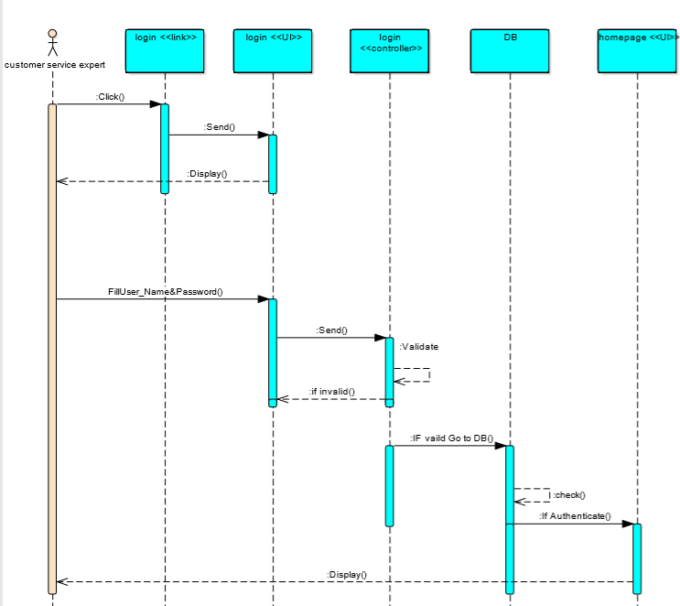

Sequence diagram for register customer

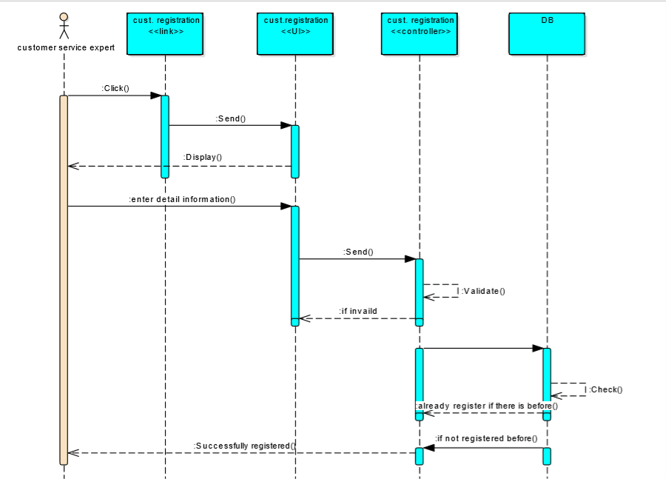

Sequence diagram for update customer

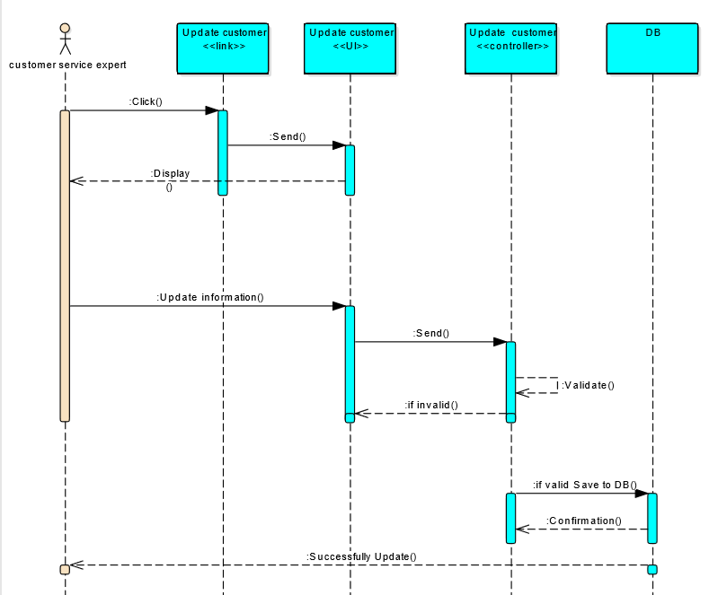

Sequence diagram for delete customer

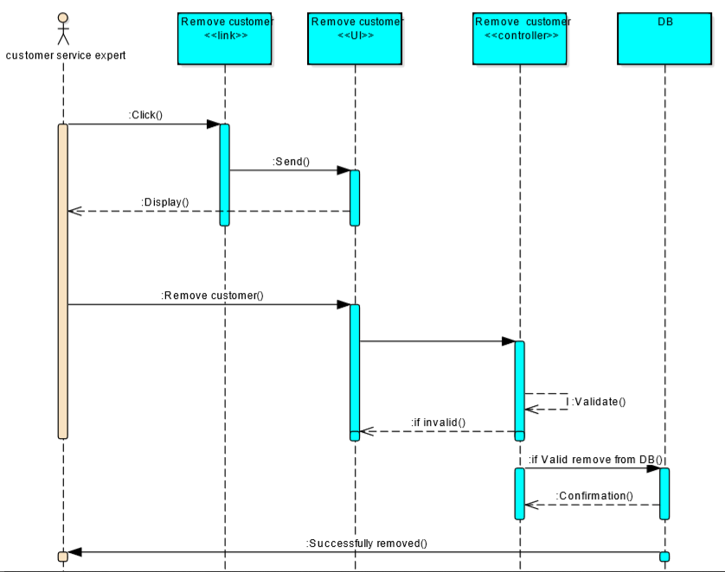

Sequence diagram for make payment

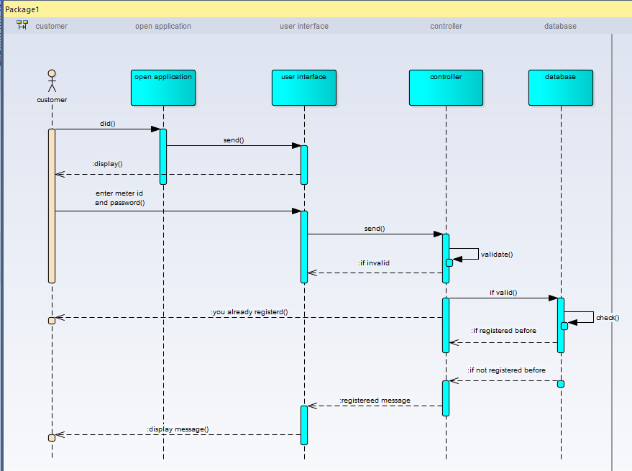

Sequence diagram for send request

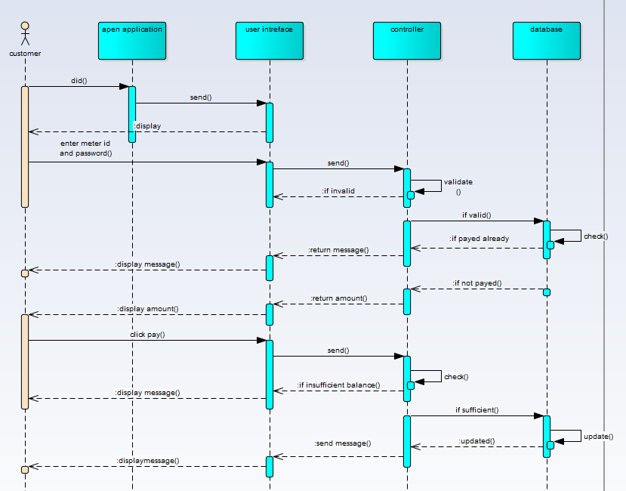

Sequence diagram for view history

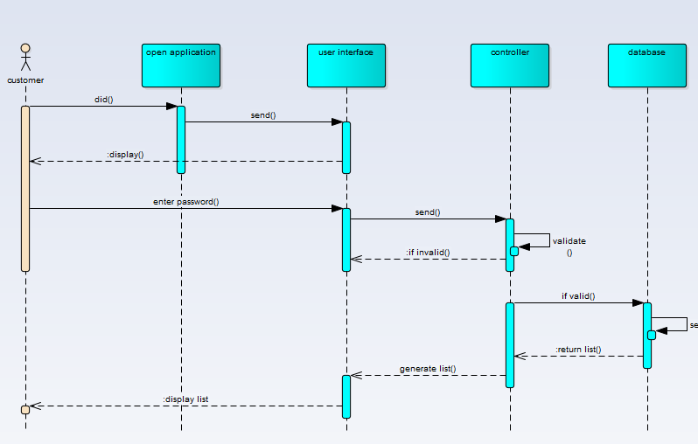

Sequence diagram for register meter

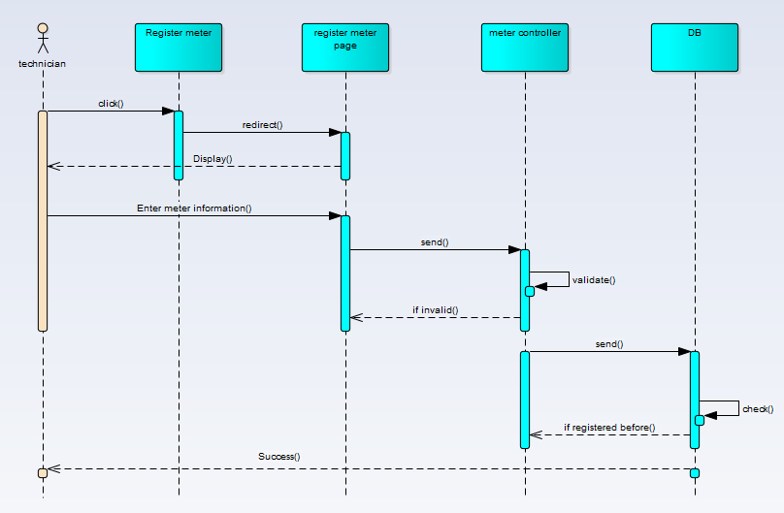

Sequence diagram for meter reading

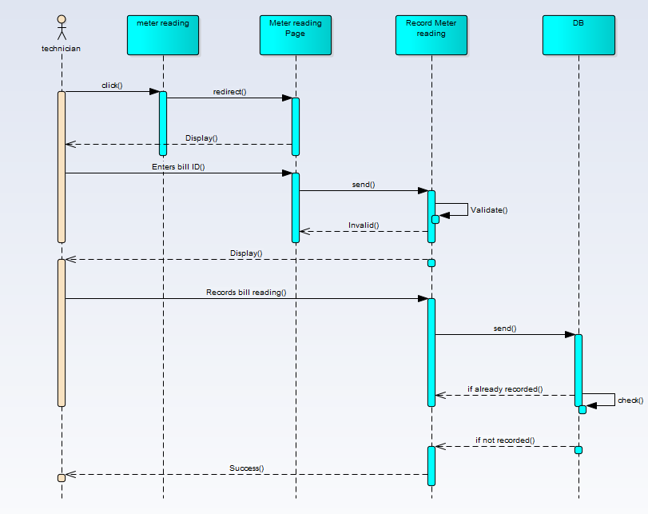

Sequence diagram for approve maintenance

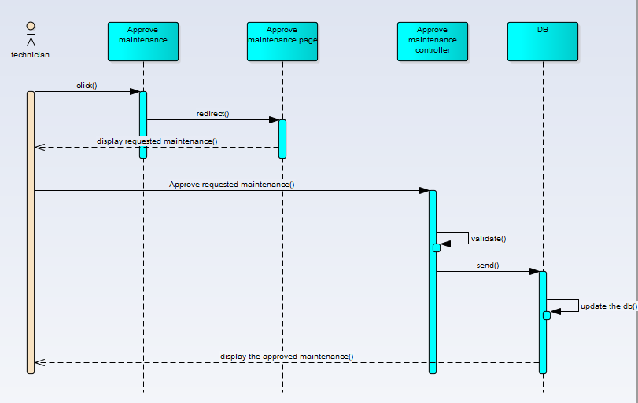

Sequence diagram for create employee account

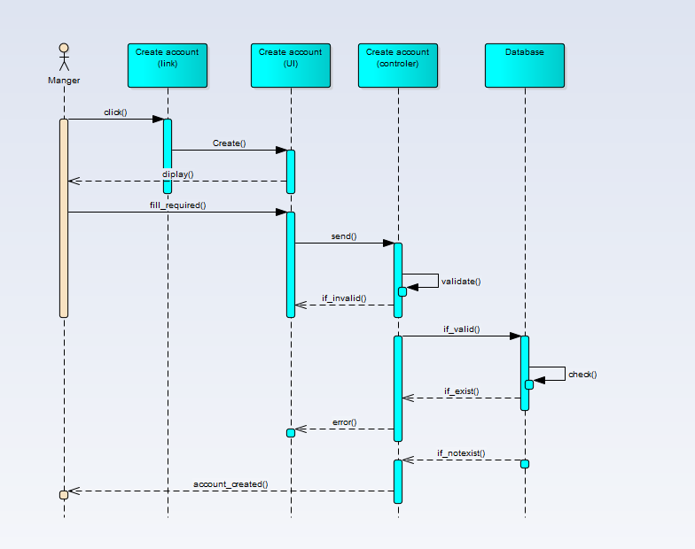

Sequence diagram for update employee account

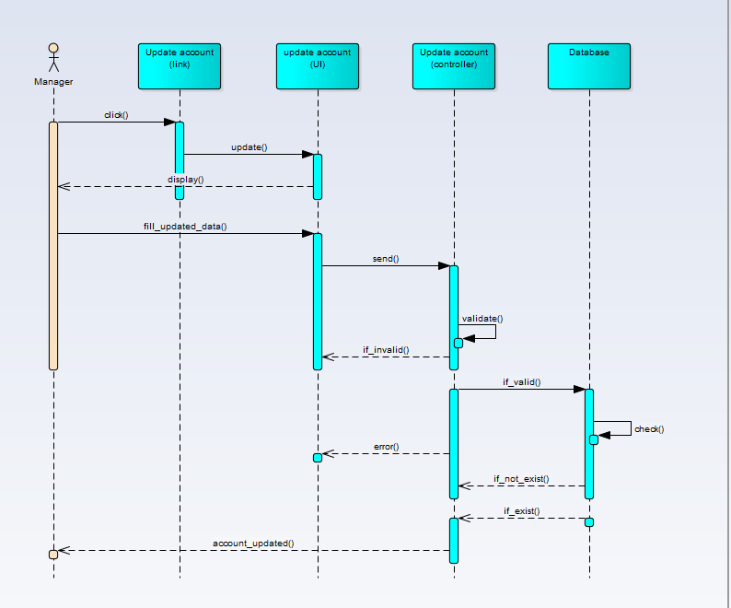

Sequence diagram for delete employee account

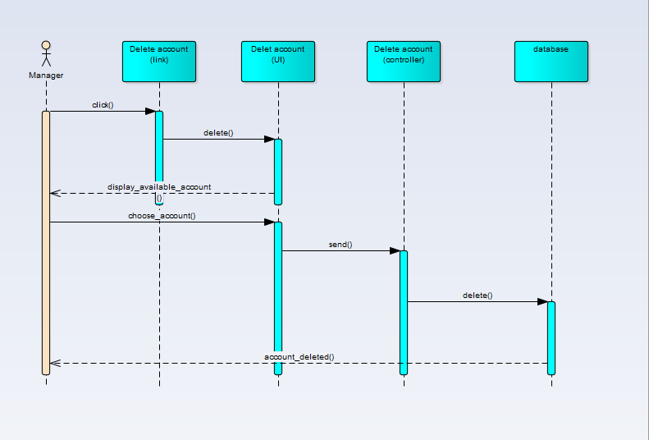

Sequence diagram for view report

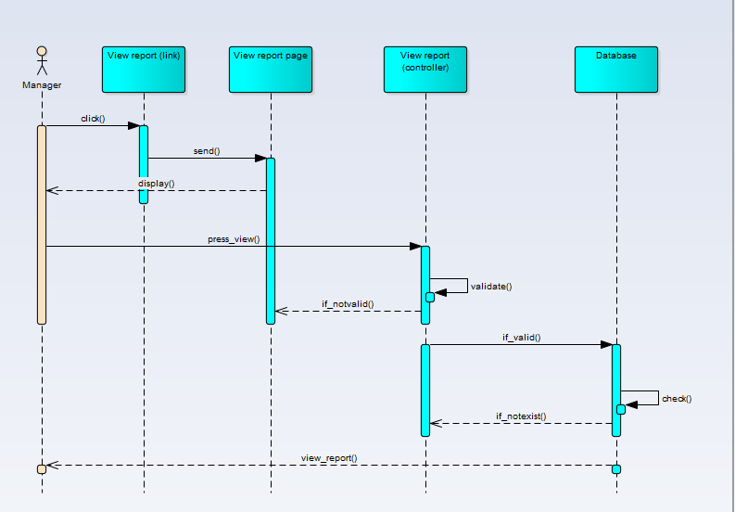

## **3.5.Class diagram**

The Class diagram captures the logical structure of the system; the classes and things that make

up the model. It is a static model, describing what exists and what attributes and behavior it has,

rather than how something is done. Class diagrams are most useful to illustrate relationships

between classes and interfaces.

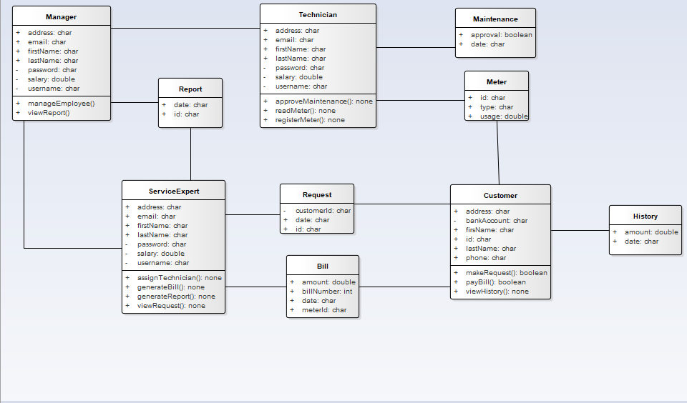

**3.6 Activity diagram**

**Activity diagrams** are graphical representations of workflows of stepwise activities and actions

with support for choice, iteration and concurrency. And show the overall flow of control.

Activity diagrams are constructed from a limited number of shapes, connected with arrows. The

most important shape types:

• *rounded rectangles* represent *actions*;

• *diamonds* represent *decisions*;

• a *black circle* represents the start (*initial node*) of the workflow;

• an *encircled black circle* represents the end (*final node*).

• arrows run

Activity diagram for customers

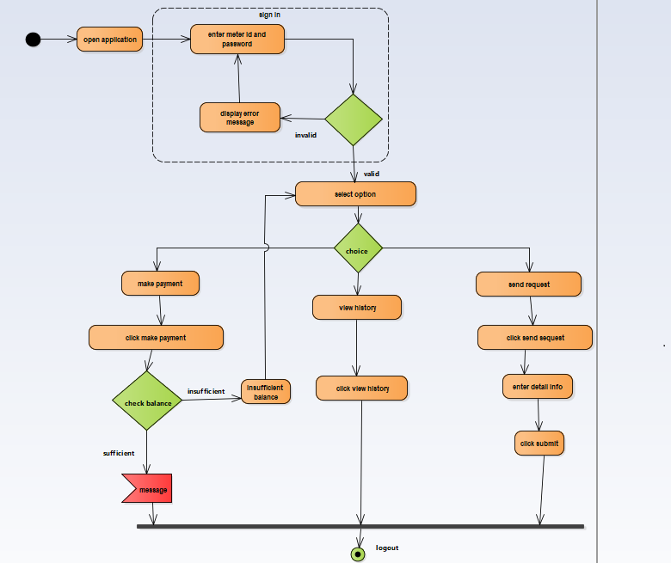

Activity diagram for customer service expert.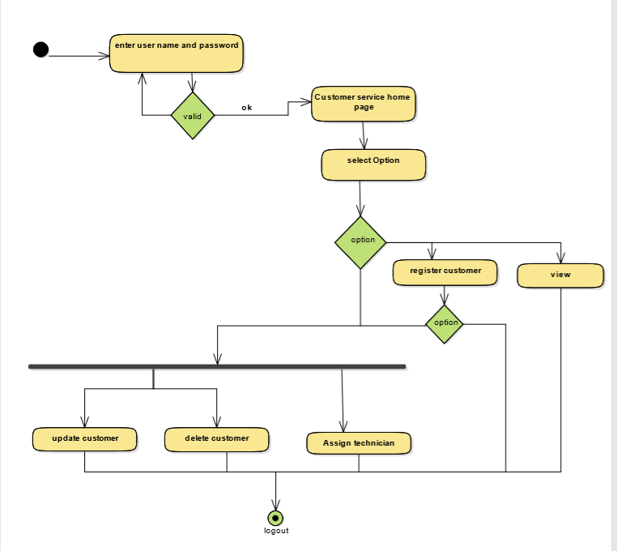

Activity diagram for technician

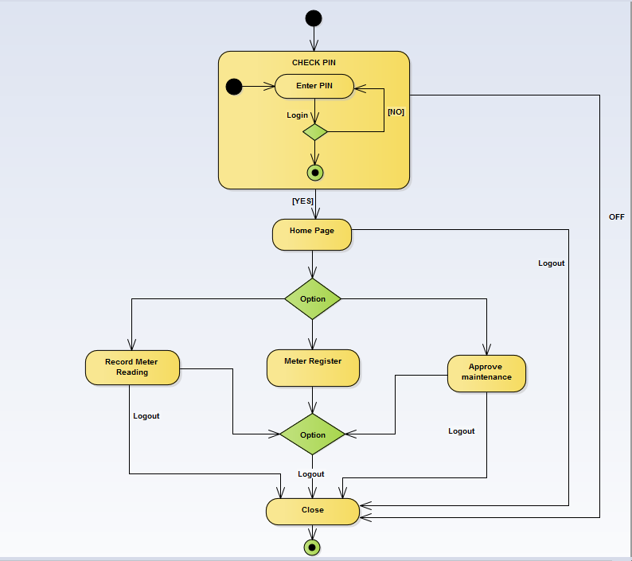

Activity diagram for manager

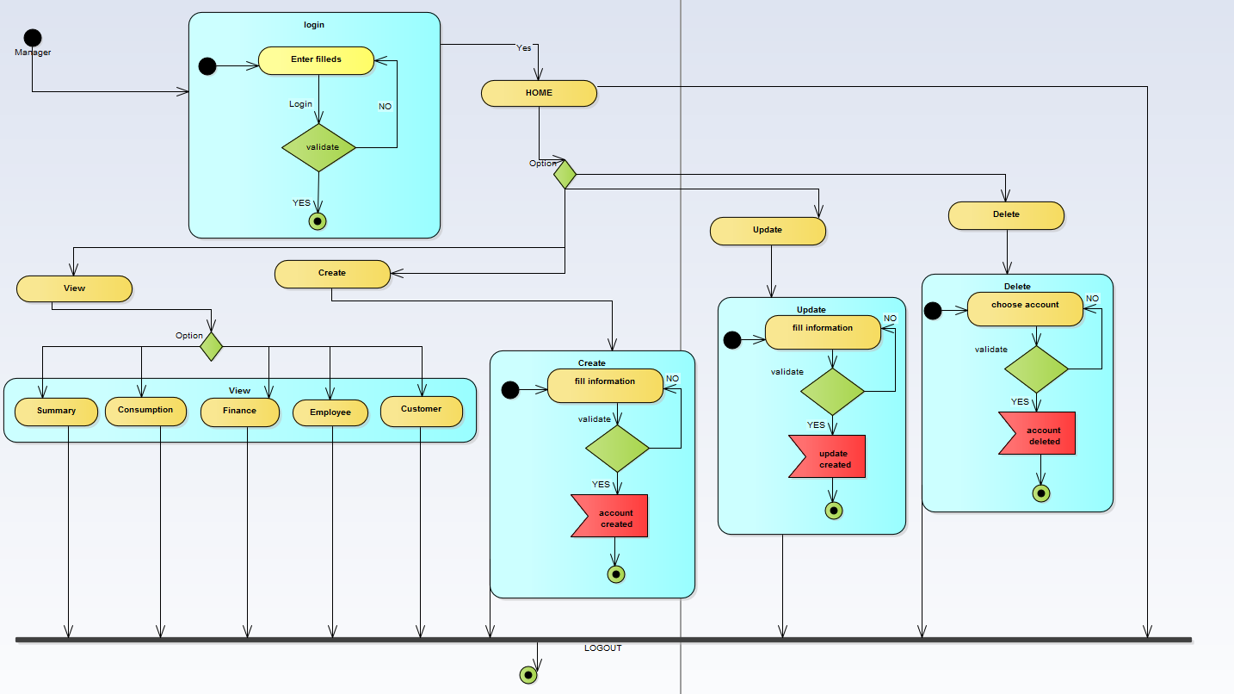

**3.7 state diagram**

State diagram for pay bill

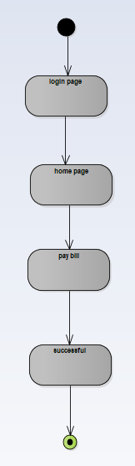

State diagram for view history

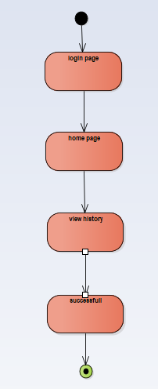

State diagram for create employee

